FoC Bulletin

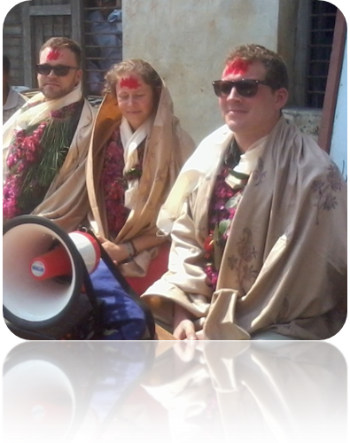Friend of children-Nepal is a non-profitable social organization established in april-2011 with the initiation of Raphael Ott, Mainz Germany. Currently, Friend of Children-Nepal has been working with the children and women of five remote village areas (Naram, Ruchang, Rakuwa, Dedhgaun and Mithukaram) of Nawalparasi District of Nepal to support poor, orphan, needy and helpless children in these areas. These five village areas are situated to the north of Nawalparasi district, which are geographically very much lacking with good transportation, communication, health service, education, drinking water etc. The villages have many small and big hills. Most of the people of these areas depend on farming with traditional ways – although few of them work in government offices, private companies, police and armies. Many youths are forced to go to the Middle East countries (Qatar, Dubai, Saudi Arab, Kuwait, and Bahrain) in search of job every year.
From the left; Raphael Ott, First Chairperson, Karin Chroszcz Second Chairperson and Tom Probst Third Chairperson, Friend of Children Nepal eV Germany
At a tribute program in the Dedhgaun Region
Political instability and lack of clear policy and its implementation have caused lots of economical, social, cultural, political problem in Nepal and the problem of poverty, unemployment, illiteracy, insecurity have become a great problem in the Nepalese community. The Nepalese kids still die of cholera and dysentery and more than 5000 children still go by their lives on the street. Nearly, 2 million kids are forced to work as the laborers. The 40 percent out of the total population is occupied by the children in Nepal whereas no serious act has been carried out by the government. The fact shows that many children of the country are deprived of their minimum requirements which are essential for their daily life. In this way, Friend of Children – Nepal has been working for the change, development, and transformation of the Nepalese community supporting to the children, women, poor families, schools, communities and other many child concerned bodies in different way.
Here, we would like to present all the supporting programs and activities that Friend of Children Nepal has got made till today! But at first, we would like to send our very special credit of course to our three friends living in Germany; Raphael Ott, Karin Chroszcz and Tom Probst and all the patrons, friends ,well-wishers of so kind heart in Germany who have made such a great deed to the Nepalese community and its people.

- Scholarship Program:
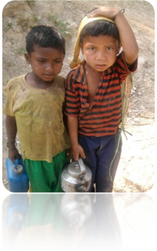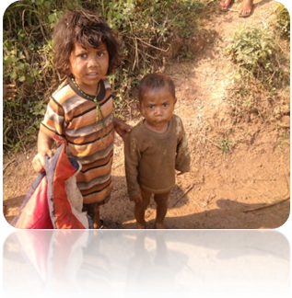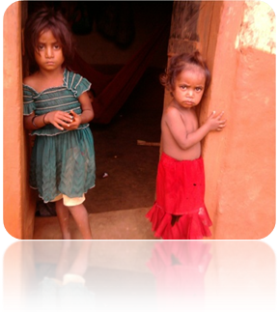

Scholarship Program has been thought as the major program of Friend of Children Nepal. Poor, needy, orphan children having very poor economic status and have not been able to go to school are supported under this program annually. The program contains the school materials; big enough for the children for one year. The children in different number since 2010 have been supported under this program.

Year | Girls | Boys | Total
2010 | 18 | 12 | 30
2011 | 23 | 27 | 50
2012 | 38 | 42 | 80
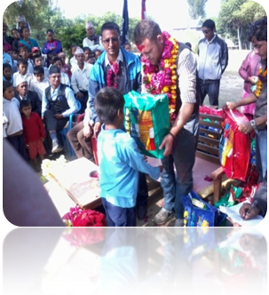 | 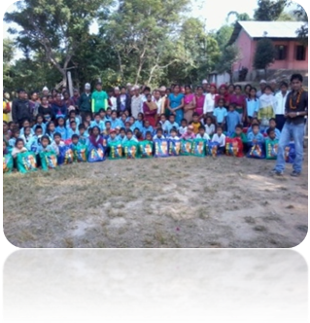79 | 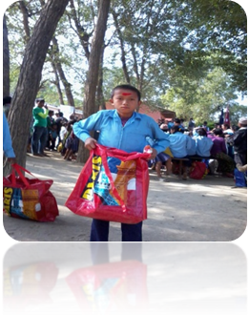81 | 160

- School Support Program:
The schools having very poor economic status are supported under this program to ensure the children’s right to quality education.
Year | Support Program | School’s Name
2010 | Wall Painting, and Carpet for floor sitting | Siddha Primary School, Rakuwa
2011 | Office Cupboard | Nagardada Secondary School, Naram
 | 20 Sets Furniture | Nagardada Secondary School, Naram
 | 10 sets White Board; dustless class | Nagardada Secondary School, Naram
 | 10 Sets White Board; dustless class | Dedhgaun Higher Secondary School, Dedhgaun
 | NRS. 50,000 support; for teachers salary | Nagardada Secondary School, Naram
 | NRS. 10,000 support; for making fence and wall plaster | Siddha Primary School, Rakuwa
2012 | Sport Dress | Nagardada Secondary School, Naram
 | Sport Dress | Dedhgaun Higher Secondary School, Dedhgaun
 | NRS. 15000 for white boards | Siddhi Primary School, Mithukaram
 | NRS. 20000 for Furniture | Siddhi Bidhyashram Lower Secondary School, Mithukaram
2013 | 10 sets White Boards; dustless class | Bel Bhanjyang Secondary School, Rakuwa
 | 3 sets White Boards; dustless class | Durga Primary School, Rakuwa
 | 3 Sets White Boards; dustless class | Siddha Primary School, Rakuwa
 | Carpet for floor sitting; Pre- School kids | Matribhumi Primary School, Rakuwa
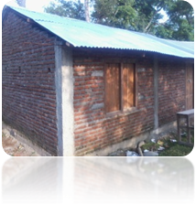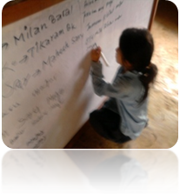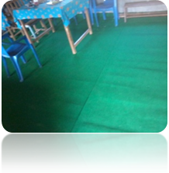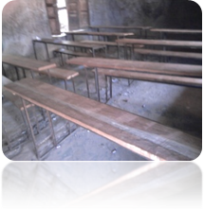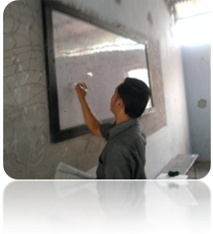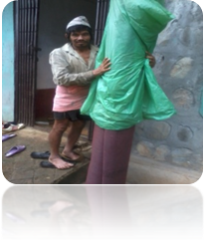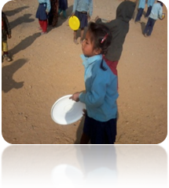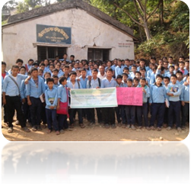
- Community Support Program:
Year | Support Program | Area
2011 | Drinking Water | Dedhgaun, Tirandi; Dalit Village
 | Toilet materials support; for open defecation free area | Dedhgaun, Tirandi; Dalit Village
2012 | Improved Cooking Stoves; Smokeless House | Dedhgaun, Tirandi; Dalit Village
 | Drinking Water; Balighat Area | Balighat Area
 | Homework Centre | Dedhgaun, Tirandi; Dalit Village
2013 | Homework Centre | Dedhgaun, Tirandi; Dalit Village
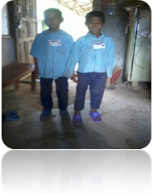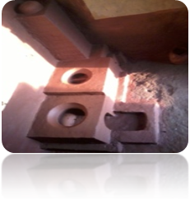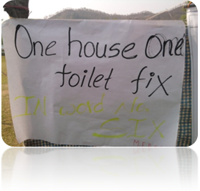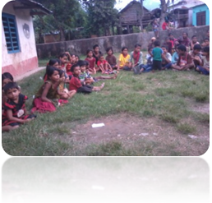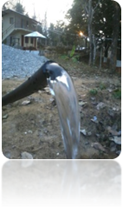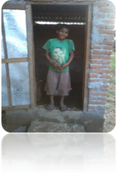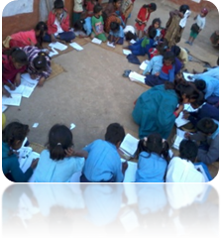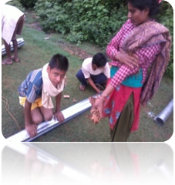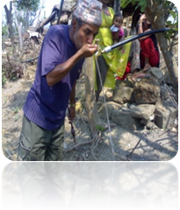
- Others:
- Two single women, supported to buy goats.
- NRS. 10000 support; for big sports meet in Dedhgaun where children from 39 schools of Dedhgaun region got participated.
- One girl, whose parents are totally deaf, have been supported finincially for studying Grade 11 and 12
- A couple in Rakuwa village had been supported to build one house. FoC provided the materials and the community people had greatly helped to work.
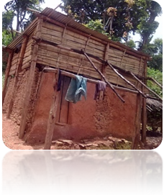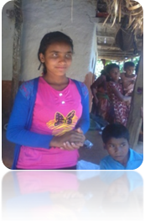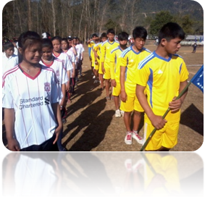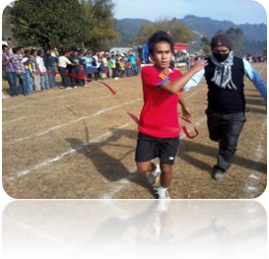
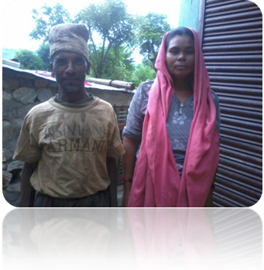

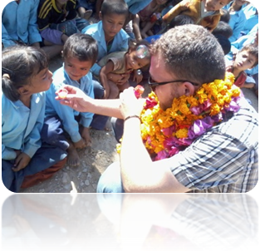
Once again, we would like to thank Friends of Children Nepal e.V Germany; our friends Raphael Ott, Karin Chroszcz, Tom Probst and all the donors, friends, well wishers who have made a great support to the children and women of Nepal. We humbly invite all the kind hearts from the different parts of the world to get involved in searching the grins on the poor innocent faces!!!
Raphael uncle; playing with kids with their best bubbles at the schools of dedhgaun region
Your small support will bring a great change to the lives of these children!!!

Sincerely Namaste!!!

Ganga Biswakarma

Chairperson

Friend of Children Nepal/Nepal

